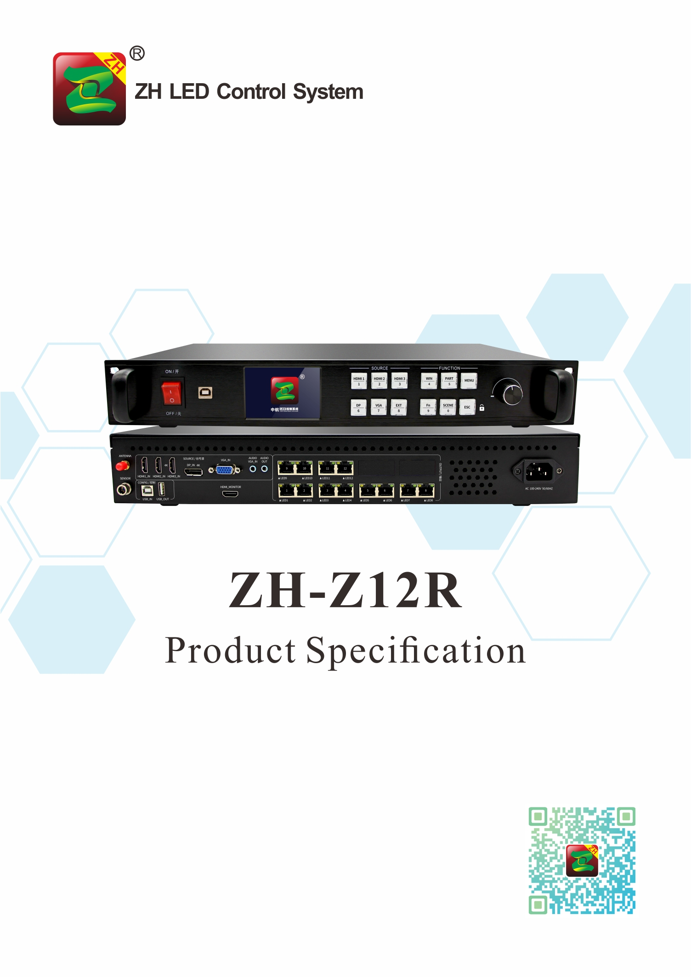

Product Specification
ZH-Z12R
I. Product Introduction:
ZH-Z12R two-in-one multi-window video player is a product produced by ZH to meet the convenience of large LED screen installation. It supports HDMI, DP and other high-definition signal input; support max pixel 4096*2160@60Hz, 12 PCS Gigabit Ethernet port output, single device supports pixels: Max width 8192,or Max Height 4096. Adopt new communication architecture, high refresh, high brightness, new grayscale scanning engine, nanosecond synchronization, and communication can be maintained smoothly under bad communication conditions, allowing users to experience a more colorful and better LED world!

II. Functional Features：
- Input interfaces, 1pcs HDMI 2.0, 2pcs 1.4, 1pcs DP, 1pcs VGA;
2. Input resolution: Max pixel is 4096*2160@60Hz,supports arbitrary setting of resolution;
3. Single card Max loading: 7.8 million points, Max Width 8192, Max Height: 4096;
4. Support arbitrary switching of video sources, splicing and zooming input images according to the resolution of the display screen;
5. Support four-picture PIP, PBP;
6. Support output screen preview;
7. Support audio input and output;
- Support brightness and color temperature adjustment
- 12 PCS Gigabit Ethernet port output, support arbitrary splicing up and down, left and right;
- Support hot backup: two network ports in the same group for hot backup and multi-card hot backup;
- Support low brightness and high gray;
- Support ZH full series of receiving cards, multi-function cards, and fiber optic transceivers;
- Support engineering lock.

III. Topology Diagram:
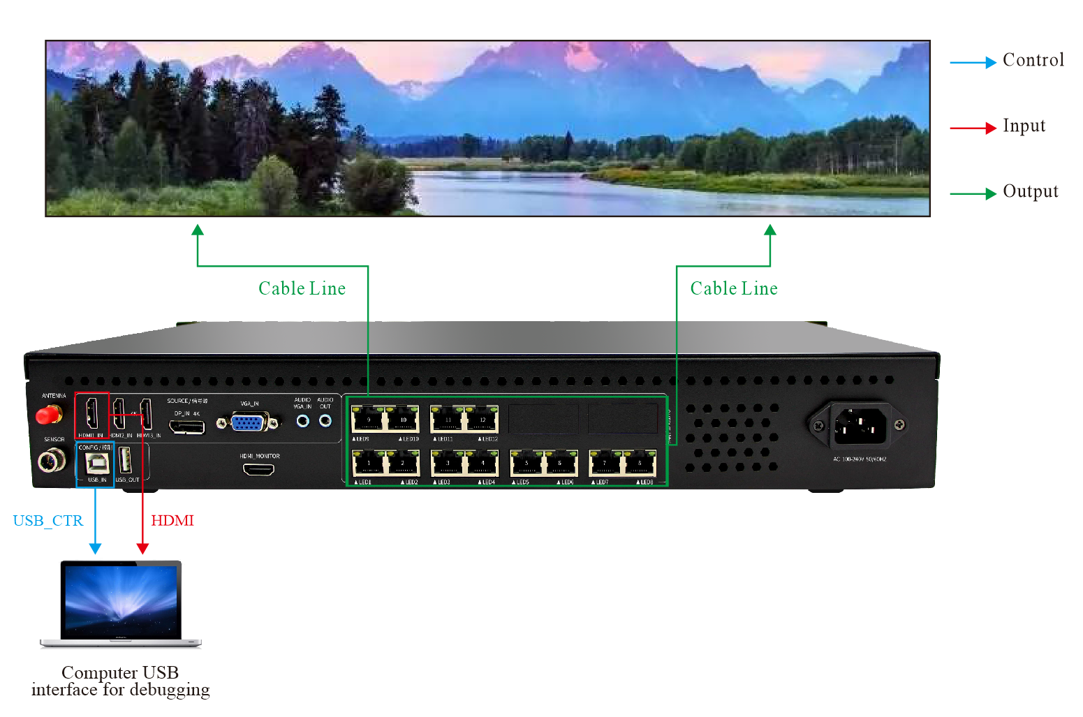
IV. Hardware Introduction:

The Front Panel

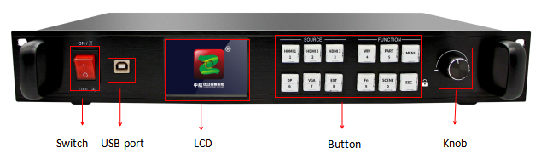
Switch | The power switch
USB Port | PC software setting port
LCD | Displays detailed prompts for user
Knob | Adjust the LED screen resolution and confirm

Button Part Manual
SOURCE |  | FUNCTION
HDMI/1 | HDMI 1/number 1 | WIN/4 | Multi-window settings/number 4
HDMI/2 | HDMI 2/number 2 | PART/5 | Partial and Full switch/number 5
HDMI/3 | HDMI 3/number 3 | MENU | Enter the menu advanced setting mode
DP/6 | DP/number 6 | FN/9 | Compound key/number 9
VGA/7 | VGA/number 7 | SCENE/0 | Scene shortcut key/number 0
EXT/8 | EXT/number 8 | ESC | Back

The Back Panel

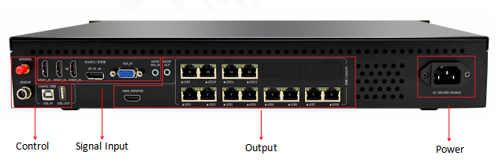

CONFIG |  | Single Input |  | Single Output
USB_IN | System setting | HDMI_IN*3 | HDMI input | LED*12 | LAN output 1--12
USB_OUT | Device cascade debugging interface | DP_IN 4K | DP input | AUDIO_OUT | Audio output
ANTENNA | 4G antenna port | VGA_IN | DP input | HDMI_MONITOR | Screen preview
SENSOR | Sensor(optional) | AUDIO VGA_IN | VGA audio input
Input:

Port | Quantity | Resolution
HDMI 1.4 | 2 | Stander EIA/CEA-861
HDMI 2.0 | 1 | Stander EIA/CEA-861, match HDMI-2.0 stander, support HDCP2.2
VGA | 1 | Support 1920*1200/60Hz and so on, match VESA stander resolution
DP | 1 | Match DP-1.2 stander, support HDCP1.3
AUDIO | 1 | 3.5mm stander audio input port
USB | 1 | Standard USB2.0port

Output:

Port | Quantity | Resolution
LED | 12 | Standard Gigabit Ethernet port, support ZH V5 all types of receiving cards, support arbitrary splicing up and down or left and right
AUDIO | 1 | 3.5mm standard audio output port

Chassis parameters:
Power Input | AC 100~240V，50/60Hz,not more than 1A
Temperature | -20~45℃
Size | 482*281.5*66.5(mm,L*W*H)
Weight | 4KG

VI. Hardware Diagram:
Unit: mm

